Steps on how to update/edit a username:
1.) From the PASS menu, select PromisePoint user list:
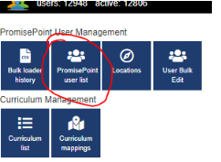
2.) Then, find the username (using the filters) that needs to be changed and click on the pencil to edit the profile:
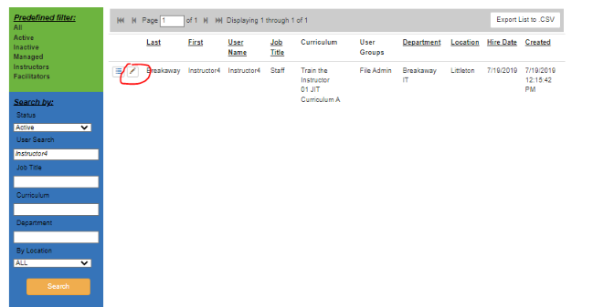
3.) The edit profile page will display, click on the Edit Profile option to access the Edit Profile section and in Username field, key in the updated username and click Save:
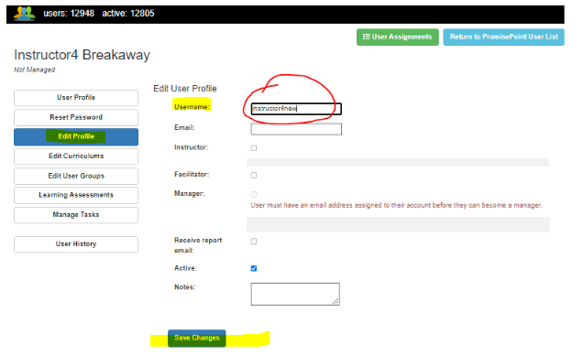

4.) Return to the PromisePoint User List to view the new username to make sure it successfully saved:

